Investigation and Comparison of Light Emission Technologies

Alex Dell, Adam C. Gold, John D. Roebker, Daniel R. Schilling, and Douglas G. Frank¹
The Schilling School for Gifted Children, Cincinnati, Ohio, USA

The spectrum and angular distribution of emitted light from multiple incandescent, compact fluorescent, and LED light sources were measured. The measurements were used to investigate the efficiency and utility of the generated light for human visualization. In addition to the educational value of this study, the results are relevant to the discussion of environmentally friendly lighting strategies.

Introduction
Modern societies are currently asking several environmentally relevant questions pertaining to conservation, sustainability, pollution, and waste. A popular trend is to replace incandescent bulbs with compact fluorescent (CFL) style bulbs, since a significant portion of the electricity we produce is used for lighting and CFLs use a fourth as much energy as incandescents. Governments have even begun implementing legislation which enforces the conversion. Our Applied Physics class decided to explore the question more carefully, since there are multiple aspects to the question and many of them are technically complex.
For this study, we evaluated two incandescent, two CFL, and three light-emitting diode (LED) bulbs (see Table 1). For each bulb, we measured the optical spectrum and angular distribution of the emitted light. The spectra revealed how much of the emitted light was useful to the human eye, and how it would appear. Our measurements and calculations confirmed our qualitative observations that LED bulbs appear the ‘bluest’. Our measurements of angular intensity helped us determine the directionality and efficiency of the light produced. As expected, the LED bulbs behaved more like spot lights, and the light emitted from incandescent and CFL bulbs was more uniformly distributed. We also did a cost-analysis for each lighting strategy, where we compared the total amount of light produced by each type of bulb with the total energy required for its manufacture, use, and disposal.
In the end, our research and analyses suggest that the best lighting strategy depended upon the application. For example, tube fluorescents are currently the most cost-effective and energy efficient means by which to deliver large amounts of non-directional lighting (good for offices and classrooms), exceeding CFLs by a factor of two and LEDs by a factor of five. When localized or directional lighting is preferred (such as desk lamps, track lighting, and automobile tail lights) LED lighting is the clear winner. While the technologies for generating light with incandescents and CFLs have plateaued, the energy efficiency of light production with LED technology continues to advance, currently equaling that of fluorescents and exceeding that of incandescents. LED efficiency is expected to surpass that of CFL by a factor of two within five years, and as manufactured quantities increase, the cost effectiveness of LED lighting will make it increasingly attractive in many applications.

Materials and Methods
The incandescent and CFL bulbs used in this study were new, and purchased locally. The LED bulbs were purchased from the C. Crane company.

Incandescent Bulbs. Two incandescent bulbs were employed, the Phillips “DuraMax” 60W and the General Electric “Super Soft White” 100W. Both bulbs had phosphorescent coatings, but the orientations of the filaments were different, Figure 1. Both bulbs were designed for general use.

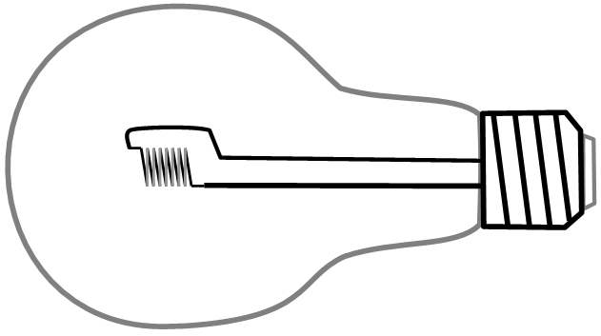
100 W
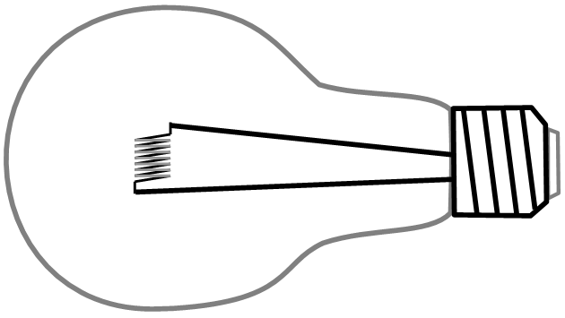
60 W
Figure 1. Incandescent bulbs used in this study. The filament of the 100W bulb was oriented along the axis of the bulb, and the filament of 60W bulb was oriented perpendicular to the bulb axis.

Compact Fluorescent Bulbs. Two n:vision CFLs were used, equivalent to the light output the 100W and 60W incandescents. Although designed for general use, neither bulb is compatible with dimmer switches.

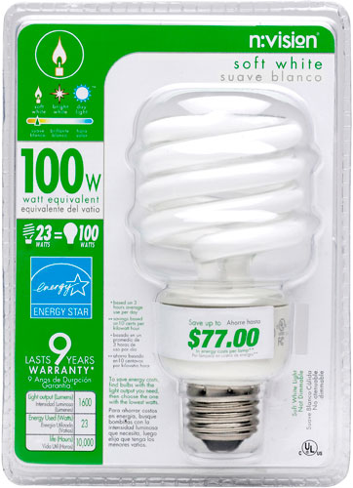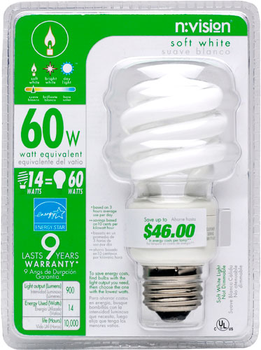
Figure 2. Compact fluorescent bulbs used in this study.

Light Emitting Diode Bulbs. Three LED bulbs were studied, each designed for different applications. The Sun’s Dusk bulb is for situations where only minimal light is needed, such as ambient or accent lighting. The CCVivid bulb is suitable for desk lamps or reading lamps, and the CCVivid Plus is suitable for task lighting. All the LED lights are dimmable.

“Sun’s Dusk” “CCVivid” “CCVivid Plus”
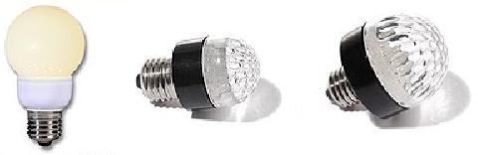
Figure 3. LED bulbs used in this study. The Sun’s Dusk and CCVivid bulbs use 18 LED’s, and the CCVivid Plus uses 36 LEDs.

Angular Distributions. The light emitted from the various bulbs as a function of angle was measured as illustrated in Figure 4. A large area silicon photodetector and custom amplifier were positioned 1.0 meter from the light source. Each bulb was rotated manually and aligned on the supporting tables, which were pre-marked with 10° angular graduations. Output was in volts and read on a voltmeter. The incandescent bulbs were measured in more than one orientation, due to the configuration of the filament and observed variations in the uniformity of the phosphorescent coatings. The sensitivity of the photodetector varies with wavelength as shown in Figure 5.

Figure 4. Measurement of light emitted as a function of angle.

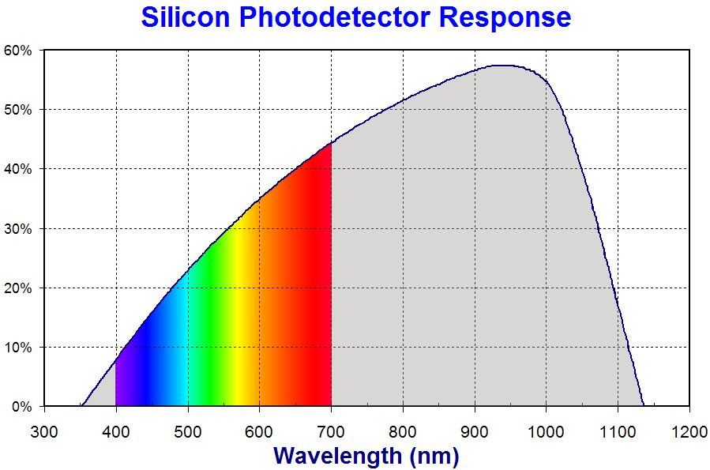
“IR”
“UV”
“Visible”
Figure 5. Silicon photodetector sensitivity as a function of wavelength. In this work, we refer to wavelengths between 400-700nm as visible, wavelengths less than 400nm as ultraviolet (UV), and wavelengths greater than 700nm as infrared (IR).

Spectrometer. The equipment used in this study was purchased from MeasureNet. The MeasureNet data-acquisition system facilitates data collection in the science teaching laboratory by integrating multiple measurement types, including light spectroscopy. The Ocean Optics S2000 spectrometer (which uses a Sony ILX511 linear CCD-array detector) is the spectrometer integrated in our system. The spectrometer sensitivity function is shown in Figure 6.

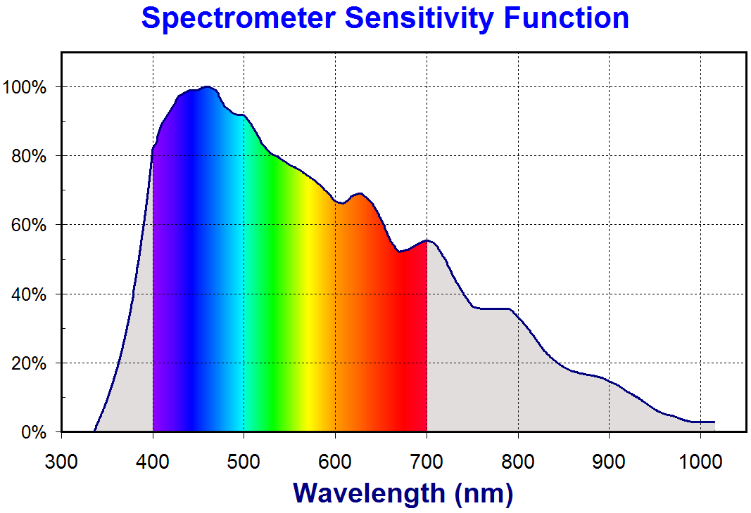
Figure 6. Normalized spectrometer sensitivity function versus wavelength.

Spectral Data
Emission Spectra. Representative emission spectra for each of the bulbs used in this study are shown in Figure 7. The characteristics of each spectrum illustrate the origins of each type of light.
Incandescent bulbs produce light by resistively heating a filament, which emits light energy over a broad range of frequencies due to its temperature. In contrast, fluorescent bulbs only emit light energies corresponding to the atomic excitations of the particular gases in the bulb.
White LED’s are modified blue LED’s, where the blue LED is covered with a yellowish phosphor coating which efficiently converts some of the blue light (the large peak near 440nm) to a broad spectrum (centered about 580 nm). Mixing the blue light with the phosphor spectrum gives the appearance of white.
Note that a significant portion of the emitted light from the incandescent source consists of IR radiation (gray region, wavelengths larger than 700nm), whereas nearly all of the light emitted from the CFL and LED sources is,
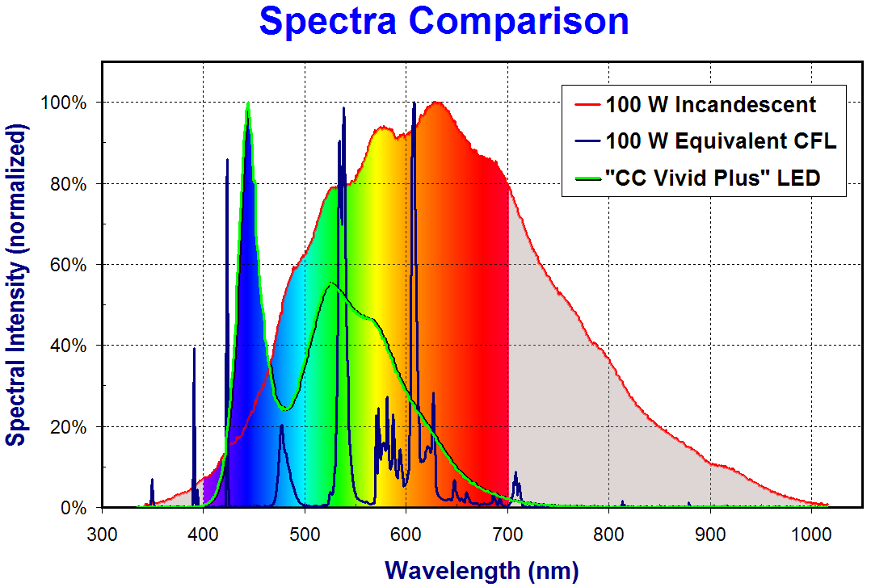
Figure 7. Representative spectra for each light source. For ease of visualization, the raw spectra have been normalized so their maximum values are 100%.
visible (rainbow region). During their operation incandescent and CFL’s become hot to the touch. In other words, incandescent and CFL bulbs both waste energy in the form of heat, and the incandescent also wastes energy in the form of invisible (IR) light radiation.
The spectrometer does not measure light of each wavelength with equal sensitivity. Thus, to more quantitatively determine the fraction of visible light in each spectrum, it is necessary to first normalize each spectrum with the spectrometer sensitivity function (Figure 6). Since the spectrometer detects strongly in the blue region and weakly in the IR region, normalizing for spectrometer sensitivity has the effect of attenuating the spectra in the blue region and amplifying them in the IR region.
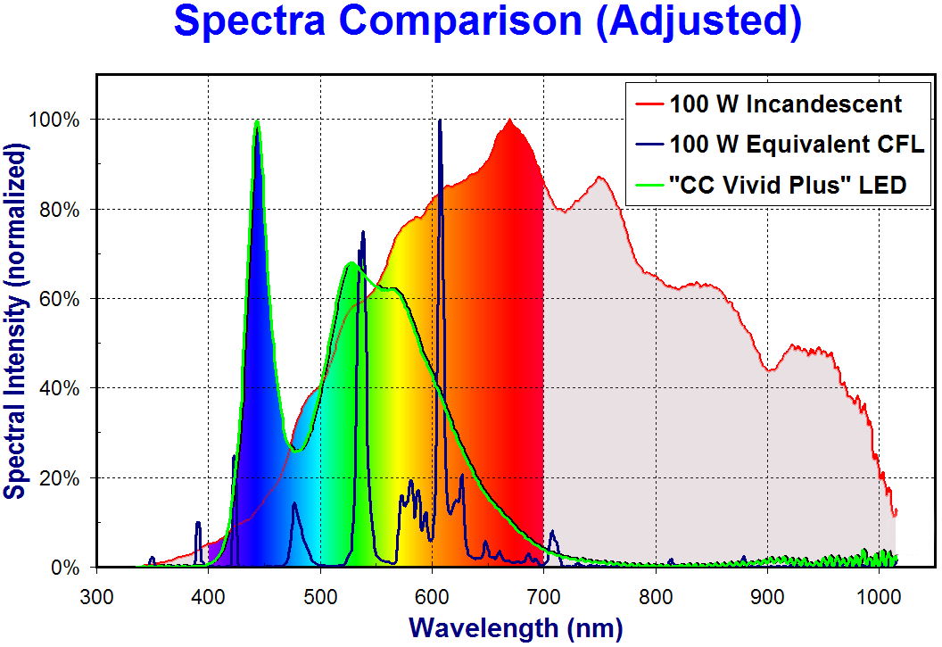
Light Source | Fraction of Visible Light (400-700nm) in Spectrum | Photodetector Visible Correction Factor, PDVCF
Incandescent, 60W | 68% | 1.79
Incandescent, 100W | 70% | 1.85
Fluorescent, 60W | 95% | 3.14
Fluorescent, 100W | 96% | 3.20
LED, SD | 97% | 3.10
LED, 30 lumen | 99% | 3.71
LED, 60 lumen | 99% | 3.93
Figure 8. Representative spectra for each light source, adjusted by the spectrometer sensitivity and normalized for ease of visualization.
Now that the spectra more accurately represent the true light emission from each bulb type, we can calculate the fractions of visible light from each bulb, Table 1.
Do the calculations…
Make a table
Put the table here
Discuss the table

Table X. Spectrum characteristics and photodetector corrections for each light source.
The ideal spectra in Figure 1b illustrate show that
more uniformly distributed across the visible region, while others have sharp peaks.
Note that nearly all of the CFL and LED intensity is concentrated in a few visible peaks,

Although the intensity of the incandescent is distributed uniformly, much of the incandescent light is outside the visible range.

What the Eye Sees. Representative emission spectra for each of the bulbs used in this study are shown in Figure

Angular

Distribution Data
Efficiency Analysis
Conclusions

Light Source | Power Consumed (W) | Light Emitted (lumens) | Lifetime (hours)
100 W Incandescent | 100 | 1710 | 750
60 W Incandescent | 60 | 830 | 1500
100 W Equivalent CFL | 23 | 1600 | 10000
60 W Equivalent CFL | 14 | 900 | 10000
“Sun’s Dusk” LED Bulb | 0.90 | 26 | 60000
CC Vivid | 0.97 | 31 | 60000
CC Vivid Plus | 1.84 | 60 | 60000

indicates that the best bulb was not as simple as choosing one over another.

To evaluate the environmental-friendliness of each bulb,

150 lumens per watt in commercial applications throughout a projected lifetime of at least 70,000 hours is ultimate LED predicted performance.
(Let there be light [gallium nitride LED]
Zorpette, G.
This paper appears in: Spectrum, IEEE
Publication Date: Sep 2002
Volume: 39, Issue: 9
On page(s): 70- 74)

LED’s are superior in certain situations

Fluorescent is superior

Long-term what will change?

The basic questions we wanted to investigate were:
- How much power is consumed by each light source?
  - How much energy to manufacture
  - Total e consumed
  - Conversion process
  - Light produced

- How much light is produced by each light source?
- What is the nature (i.e. utility) of the light that is produced?
- Environmental issues pertaining to source
  - Energy/cost to manufacture source (components, etc)
  - Energy/cost to distribute source
  - Energy/cost to dispose of spent source
  - Environmental impact of manufacture and disposal
- Birth to grave costs…
- Which lights work for which applications?

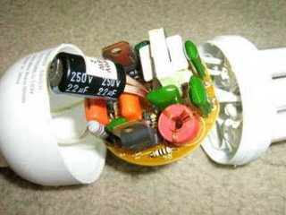

To answer these questions quantitatively and rigorously, such that a reasonable decision can be made is necessarily a long and complicated process due to all factors. Impractical for the scope of our work to include all these factors…So, for the purposes of this paper, we focus on () questions/attributes. (narrow the scope)

The fact that one of our students is colorblind led to many fascinating explorations and discussions. (Human effectiveness and human sensitivity).

Define our Scope:

Light emission
Characterize and quantify (relative)
Power (do we measure or accept manuf. specs.?)

Measure some things and research some things
Measure
Light emission
Research
Power consumed (right on the package)

Political Implication/public policy
Mathematical
Scientific process
Social phenomena vs science
Excel
Electronics
Physics of light

Common misconceptions
Educational value
Environmental impact
Climate change
Energy efficiency
Energy cost of manufacturing light
“Birth to death” equation
Energy cost of recycling bulbs

What is left over after life of bulb

When many people do the same thing, there are often unanticipated consequences
Many other experiments/discussion
Long term consequences
Political movements, fads
Land fills
Nuclear power
Knee-jerk reaction
Global trends (fads, customs)
Travel/shipping (heavier)
Packaging
Lifetime of bulb (1500h, 15000h, 60000h)
Usage in a year (hours) (what would be a ‘standard use’ for a bulb would be)
8h/d * 365d/y = 2920 hr
Claims by political officials and objectors
1W produces 25 lumens of light from LED, and 1W produces 90 lumens from fluorescent? (claim by http://forums.creativecow.net/readpost/47/855320)

(Group Version)
There is increasing discussion in our culture pertaining to the cost effectiveness and environmental impact of various types of lighting. Legislation has been passed in response, making it illegal to sell incandescent light bulbs in California, and European countries are considering proposals to ban their manufacture. Climate change is fueling the discussion, and the subject has become a frequent topic in the media.
How much of this trend is based upon clear scientific reasoning, and what is the best course of action based upon this reasoning?
To answer this question, wedecided to carefully examine the question by means of research and experiments. Our questions include environmental factors, energy efficiency, economic and technical factors.
For example, does it make sense to change all incandescent light bulbs to fluorescent ones? While it is true that fluorescent bulbs consume about 1/3 the energy of incandescents, fluorescents are more expensive to produce (energy and cost) and contain the environmentally harmful element mercury. On the other hand, since most of the power in this country is produced by burning coal, and there are mercury emissions associated with that burning, which strategy ends up emitting more mercury into the environment?
Such questions require careful analyses of the various factors, not commonly heard in public discussions.
To explore these questions, we measured light emission from at least two examples of three different types of lighting; incandescent, compact fluorescent, and LED. We did not examine LCD lighting, as the technology for practical lighting is still an emerging and not readily available to the typical consumer..

(motivations)
Climate change
Energy efficiency
Education – practical question investigation
Technological progress
Refer to previous studies (RESEARCH)

Adam
It would be interesting to quantitatively measure the heat output of the lights and all the other factors that would pertain to the total energy efficiency of the lights. Such as the average cost of cooling, etc.
LED’s seem to be the coolest, for example, then fluorescent, then incandescent.
How much energy into heat, and into light.

Table 1. LED light bulbs used in this study.
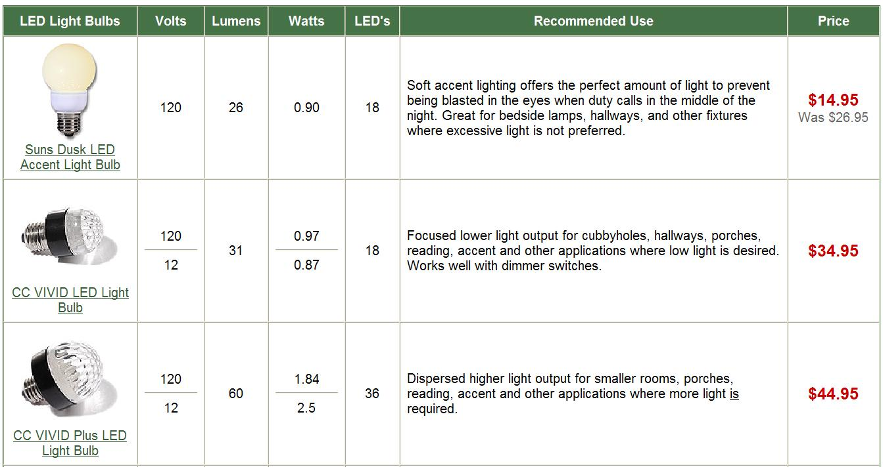

Table 2. Summary of bulb manufacturer information

Light Source | Manufacturer Power Rating (W) | Measured  Power Consumed  (W) | Visible Light Emitted | Invisible light emitted
100 W Incandescent | 100
60 W Incandescent | 60
100 W Equivalent CFL | 23
60 W Equivalent CFL | 14
“Sun’s Dusk” LED Bulb | 0.90
CC Vivid | 0.97
CC Vivid Plus | 1.84

Measurement of Angular Distributions. A silicon photodetector and amplifier were used and arranged as shown in Figure 3. Ten degree increments were pre-marked on tables with a protractor, and the light was rotated as shown, keeping the detector fixed.

Figure 3. Experimental setup for measurement of angular distribution of light emission.

Ocean Optics
Spectrometer

Observations
Graphs of angular distribution of intensity
Tables of data
Spectra from each light bulb

Figure x. Spectra for the Light Sources used in this work (un-normalized by spectrometer sensitivy).
Figure x. Comparison of measured and normalized spectra for the various light sources.

Figure x. Spectra normalized for spectrometer sensitivity

What is the relative sensitivity of our eyes vs wavelength?

The whitest appearing light is the LED, which has an average detected wavelength of 557nm, with a distribution that is peaked closest to the maximum in human eye sensitivity (550nm). The CFL appears ‘redder’ than the LED, with an average detected wavelength of 568nm, and the incandescent appears redder than the other two, with an average detected wavelength of 571nm. These calculations confirm the general perception that incandescent bulbs appear ‘yellowish.’

It is also interesting to note that a person with deuteranopia (red-green color-blindness), would find fluorescent lighting to appear orange, while LED lighting to appear more blue.

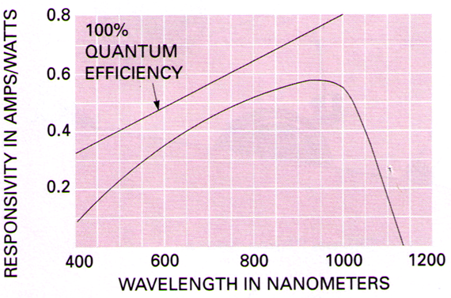
In order to find the fraction of the light that is visible, and how much is actually emitted from the bulb.

Calculations
Interpolation of angular distribution data
Integration of angular distribution data
Estimation of total emission from each bulb
Calibration of angular distribution data

Normalization of angular distribution data

φ
0°
90°
$$N\left(φ\right)=\frac{π^{2}}{\text{180}}\left[\text{sin}\left(φ\right)+\text{sin}\left(φ+\frac{π}{\text{180}}\right)\right]$$
(equation assumes φ increments of 1°)

99.9907% for a hemisphere

Not evenly coated with phosphor
Bulb not a sphere

Analysis and Discussion
Incandescent bulbs produce heat and light with a resistant filament. Fluorescent bulbs produce light by using electronics to precondition and control the voltage and current to cause the gas in the bulb to fluoresce. So, the heat we felt in the CFL when we were removing the bulb is not emitted as light, but is still an energy cost.

Si Photodetector Efficiency. The Si photodector employed in this work for making angular distribution measurements does not detect all wavelengths of light equally, as shown in Figure x. Combining this information with the known distribution of emitted wavelengths (the ‘spectrum’) allows us to calculate how much of the measured photodetector response is attributable to usable light.

The fraction of usable (or visible) light from each light source is obtained by dividing the integral of the spectrum in the visible range (400-700nm) by the integral of the complete spectrum. Table X lists these fractions for each of the lights investigated. Note that the 60W incandescent bulb produces the smallest proportion of visible light, whereas LED lights produce visible light almost exclusively. The fluorescent lights produce proportionally more visible light than the incandescents, but a bit less than the LED’s due to small emission bands in the UV and IR range (Figure x).
Fraction of Visible Light in Spectrum $=F_{\text{Vs}}=\frac{\sum_{\text{400}−\text{700}}{S(λ)}}{\sum{S(λ)}}$

where S(λ) is the spectral data, normalized such that the area under the spectrum is consistent for all the light sources.

Define fraction of vis light in pdetector spectrum
Define correction factor
Write complete equation, and simplify

Table X. Spectrum characteristics and photodetector corrections for each light source.
Light Source | Fraction of Visible Light in Spectrum | Photodetector Visible Correction Factor, PDVCF
Incandescent, 60W | 68% | 1.79
Incandescent, 100W | 70% | 1.85
Fluorescent, 60W | 95% | 3.14
Fluorescent, 100W | 96% | 3.20
LED, SD | 97% | 3.10
LED, 30 lumen | 99% | 3.71
LED, 60 lumen | 99% | 3.93

PDVCF =

For example, since the silicon photodector ‘sees’ better in the IR range, the Si photodector signal will be artificially high from an incandescent bulb (which emits significant IR). To compensate for this, we multiply the spectrum by the detector efficiency, integrate the resulting spectrum and the portion of the spectrum in the visible range (400 nm to 700 nm). The ratios of the two integrals gives the proportion of usable light directly from the Si photodetector signal, what we will call the ‘photodetector visible light factor.’ Factors for each bulb are given in Table x.

To calculate the photodetector visible correction factor (PDVCF), we multiple the percentage of visible light the pd would have picked up by the percentage of the visible light that the spec picked up
And then diviede the product by

(Vs. measuring a specruma at every angle.)

Figure X. Si Photodetector Response vs. Wavelength.

Table X. Photodetector visible light factors.

Does the ocean optics spectrometer have equal sensitivity at each wavelength?

Quantitative measurement of practical emitted
Calculation of total light emitted for each
Calculation of energy consumed for each
Energy efficiency for each light source
Distribution analysis

Could calculate:
Useful visible energy from a light source (E=hν, ∫ photons dλ)

These calcs are purely relative to themselves (only need the spectral data)
Percentage of light energy from a ls that is ‘useable’ (between 400 and 700)
Percentage of light photons from a ls that is ‘useable’ (between 400 and 700)

Conclusions

References

¹ Please address correspondence to: 10857 Millington Ct., Blue Ash, OH 45242. ? 22% of the electricity produced in the U.S. is used to produce lighting. (reference)
Reference to governments passing legislation
The Schilling School for Gifted Children, Cincinnati, Ohio USA.
MeasureNet
Factor of two, surpass CFL
C. Crane Company, Inc., Fortuna CA, USA.
Melles Griot Si Photodector, Model #13 DSI 009.
Precision Analytical Instruments, Inc., Blue Ash OH, USA.
MeasureNet Technology, Ltd., Cincinnati, Ohio, USA.
Ocean Optics, Dunedin, Fl, USA.
Sony document #E94108-TE.
San Francisco Chronicle, Feb 9, 2007, California AB 1109 (Huffman) Lighting Efficiency & Toxics Reduction Act
BBC News, Nov 2, 2006
Physics Class, The Schilling School for Gifted Children, Cincinnati, Ohio
C. Crane Company
Oriel model….
Precision Analytical Instruments, Inc., Cincinnati OH, USA, www.ToolsForAnalysis.com
Oriel

