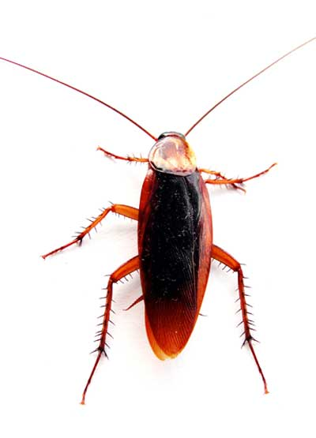
The Amateur’s Guide
Ptthhlbbt
to
Annoying Things

Based upon reliable evidence, the top scientists in the world have determined and recorded, for the reader’s benefit, the world’s most annoying and disgusting things!
Top 5 Annoying Sounds
1 | Mosquitoes
2 | Slurping
3 | Farts
4 | Burps
5 | Blowing Noses

Here to the side there are the five most annoying sounds that our world can offer. The test subjects where deafened and will probably die… but there is time for that later. By clicking on the ranking letters of the graph, you can hear the sounds for yourself.

As portrayed in Graph A, the amount of annoyances per month has been greatly increasing. These scientists have also documented that the most disgusting things on the planet are the cockroach, (cockroachicus annoyiniathus) and the mosquito. (mosquitios pestisuckus) With this valuable research at their disposal, the scientists are ready to make a large breakthrough, and change the world as we know it, forever.
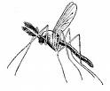
Graph A

25 per month
2005
0 per month
50 per month
75 per month
2006
2007
2008
Annoyances per Month

