The Minimoog Model D 1970

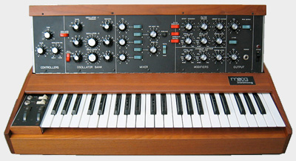
The Minimoog Model D was the first portable analog synthesizer designed for touring musicians. It was manufactured and produced my Moog Music INC. from 1970 to 1982. The Model D contained three voltage controlled oscillators (VCO’s) that helped give it the phat sound that most other synthesizers could not obtain. The Model D is also monophonic, meaning it can only play one note at a time. Before analog synthesizers were portable they were known as modular synthesizers. Conveniently, Moog was able to shrink every thing down into a small light weight synthesizer. It’s safe to say that the MiniMoog was the first instrument that made the sound of other instruments.
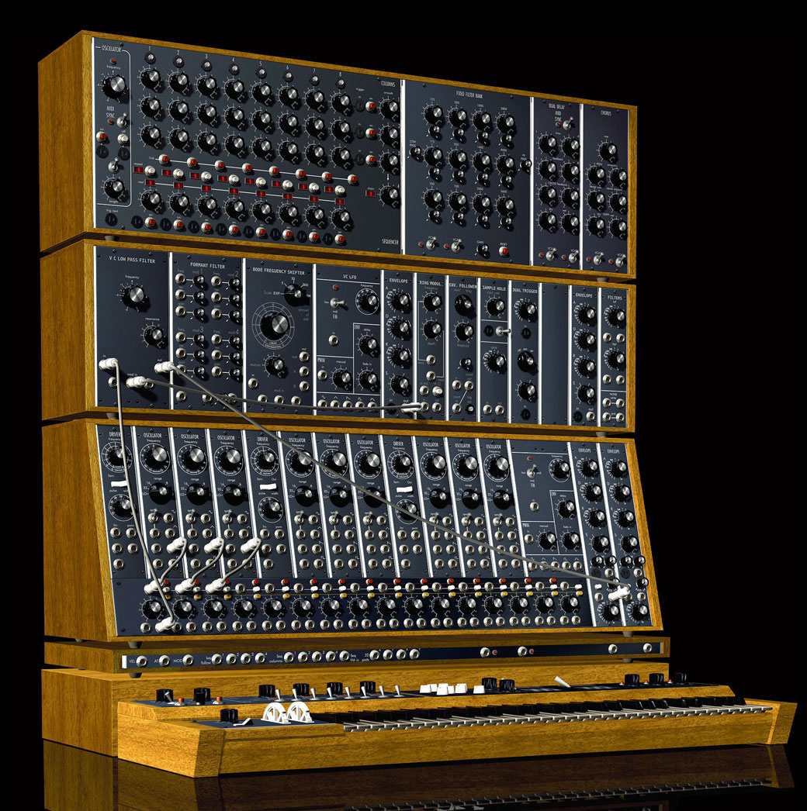
- Frank John Miranda

from this, to this

Modular patch cables

Rocker switches allow rapid sound transformation.

Rocker decay switch allows simultaneous sustain while playing.

Oscillators can move up and down up to seven octaves

Main output can be turned off for on stage tuning using the fine tune knob

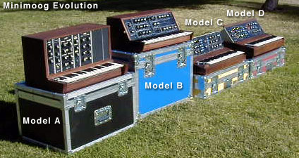

The Model A was the last model that was a modular look a like.
The C and D Models were featured
slightly different pitch and mod wheels.

A funky Moog bass

In the Hall of the Mountain King moog bass

Moog Sales for 1971

Past and Present Pricing

1970-1981 | Anywhere from  $1,200.00 - $1,500.00
2008 | Anywhere from  $4,500.00 - $6,500.00
2002 – 2008  Replica of Model D | Anywhere from  $2,500.00 - $3,000.00

Moog Keyboard

