My
Epiphone
Les Paul
Ultra

The Epiphone Les Paul Ultra was made as a response to the Fender Stratocaster.

Here is a comparison of the Fender Strat to a Les Paul
Fender Strat Epiphone Les Paul

Weighted at base of neck weighted at the bridge

Has a curved back to has flat back
conform to body

Has three pickups has two pickups

Open coiled pickups humbucker pickups

In line tuners and straight out of line tuners and
Headstock tilted back Headstock

Light heavy

Here is a comparison of the Les Paul ultra and the standard Les Paul

Ultra Standard
Weighted at weighted at bridge
Base of neck

Curved back flat back

Light heavy

The Ultra also has some unique upgrades of it’s own. The holes that are in the cavities add to the sound quality as well as the weight. The forward pickup comes upgraded as well as the tuners.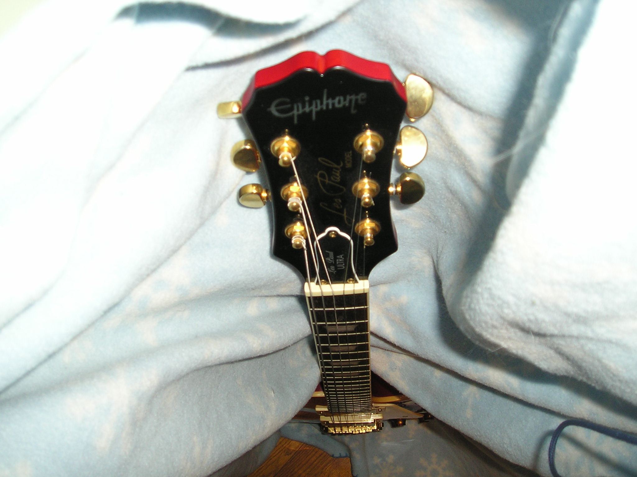 The up graded tuners
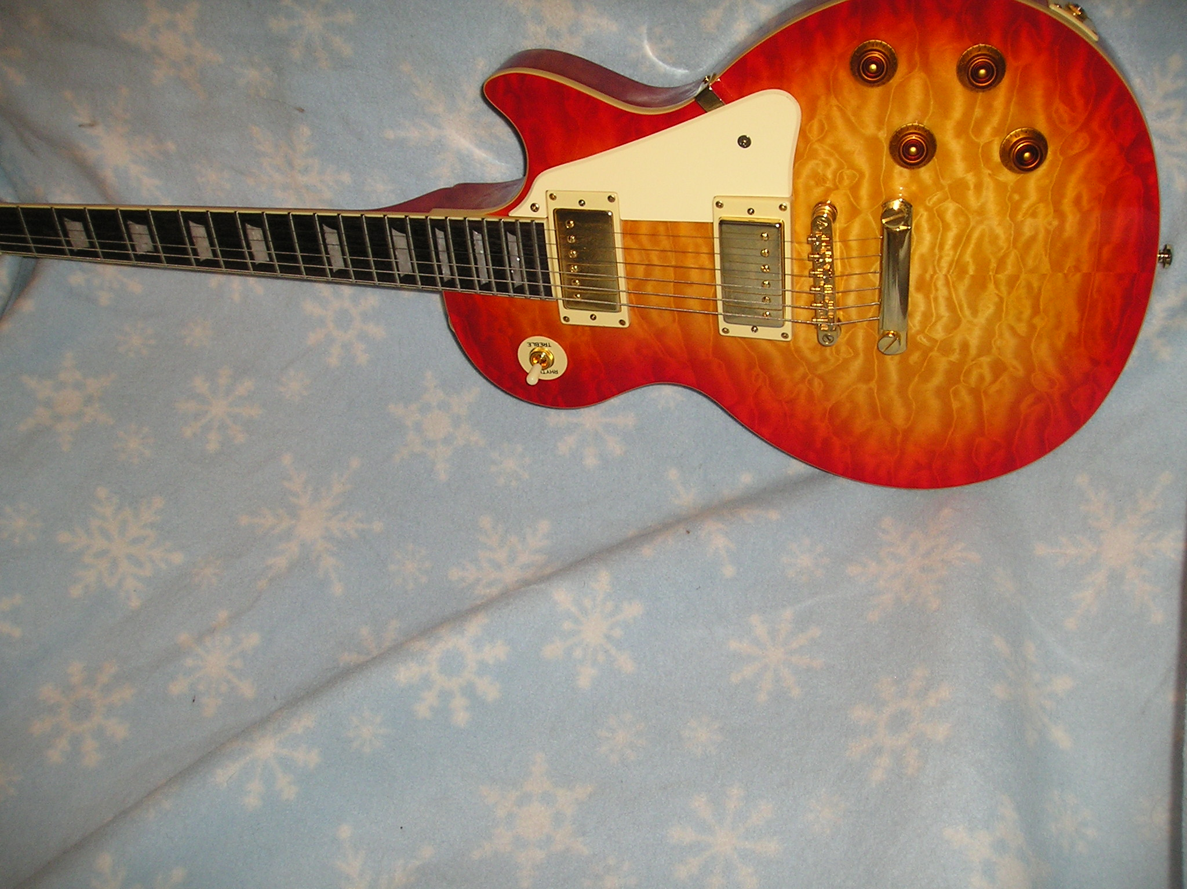The upgraded pickup

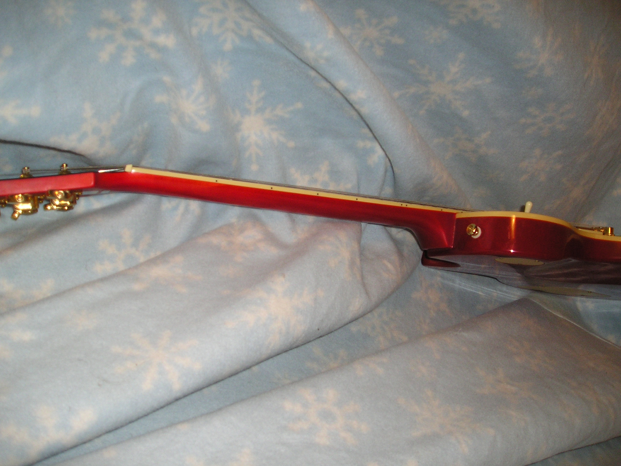 The tilted headstock

 Here is a sound clip of me playing my Les Paul

