The Eyes Have It
by Cameron Cofskey

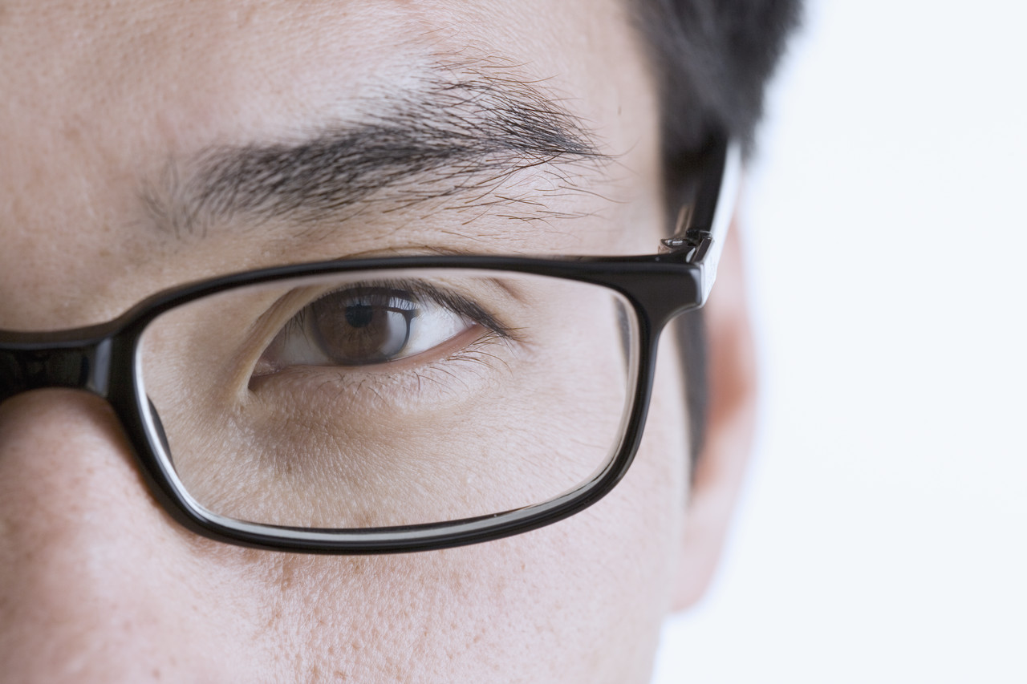
I have been interested in optometry ever since I had to get glasses, but had never done any deeper research on it until this class. I find this profession fascinating, and I hope this presentation will help you to better understand what optometry is all about.
Optometry is a health care profession concerned with eyes and related structures, as well as vision, visual systems, and vision information processing in humans.
Like most health professions, optometry education, certification, and practice is regulated in most countries. Optometrists and optometry-related organizations interact with governmental agencies, other health care professionals, and the community to deliver eye and vision care.
Optometrists, also known as doctors of optometry, or ODs, are the main providers of vision care. They examine people’s eyes to diagnose vision problems, such as nearsightedness and farsightedness, and they test patients’ depth and color perception and ability to focus and coordinate the eyes. Optometrists may prescribe eyeglasses or contact lenses, or they may prescribe or provide other treatments, such as vision therapy or low-vision rehabilitation.
Optometrists also test for glaucoma and other eye diseases and diagnose conditions caused by systemic diseases such as diabetes and high blood pressure, referring patients to other health practitioners as needed. They administer drugs to patients to aid in the diagnosis of vision problems and to treat eye diseases. Optometrists often provide preoperative and postoperative care to cataract patients, as well as to patients who have had laser vision correction or other eye surgery.
The Doctor of Optometry degree requires the completion of a 4-year program at an accredited optometry school, preceded by at least 3 years of pre-optometric study at an accredited college or university. All States require optometrists to be licensed.
Education and training. Optometrists need a Doctor of Optometry degree, which requires the completion of a 4-year program at an accredited optometry school. Requirements for admission to optometry schools include college courses in English, mathematics, physics, chemistry, and biology. Because a strong background in science is important, many applicants to optometry school major in a science, such as biology or chemistry as undergraduates. Others major in another subject and take many science courses offering laboratory experience.
Admission to optometry school is competitive. Applicants must take the Optometry Admissions Test, which measures academic ability and scientific comprehension. As a result, most applicants take the test after their sophomore or junior year in college, allowing them an opportunity to take the test again and raise their score. A few applicants are accepted to optometry school after 3 years of college and complete their bachelor’s degree while attending optometry school. However, most students accepted by a school or college of optometry have completed an undergraduate degree. Each institution has its own undergraduate prerequisites, so applicants should contact the school or college of their choice for specific requirements.
Optometry programs include classroom and laboratory study of health and visual sciences and clinical training in the diagnosis and treatment of eye disorders. Courses in pharmacology, optics, vision science, biochemistry, and systemic diseases are included.
Specialty areas for residency programs include family practice optometry, pediatric optometry, geriatric optometry, vision therapy and rehabilitation, low-vision rehabilitation, cornea and contact lenses, refractive and ocular surgery, primary eye care optometry, and ocular disease.
This is an optical refractor or a phoropter:

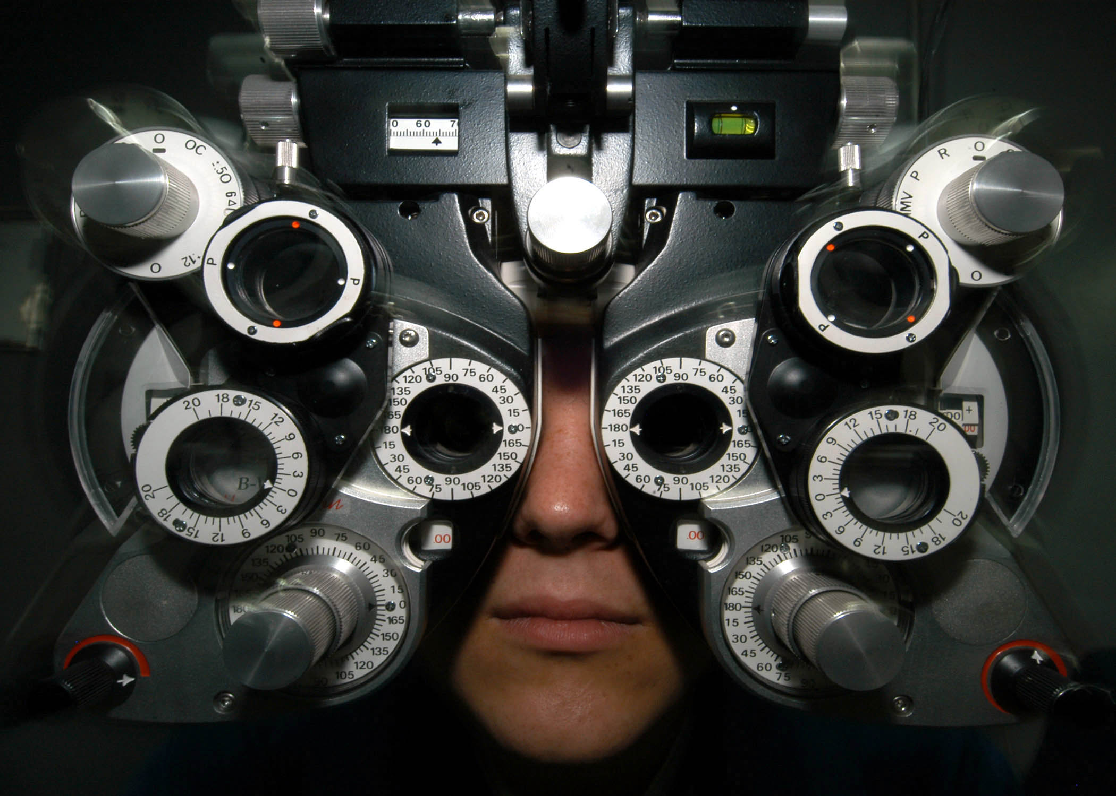

This is what the optometrists use to find out what kind of lenses they need to use in your glasses.
Here is a basic picture of the human eye:
Optic nerve
To brain
Pupil
Iris
Retina
Light/images

lens
According to the Vision Council of America (2006), of the total adult American population:
Type of eyewear | Percent
Eyeglasses | 64.0
Contact lenses | 19.0
Sunglasses | 85.6
Readers | 14.0

