All About Justin

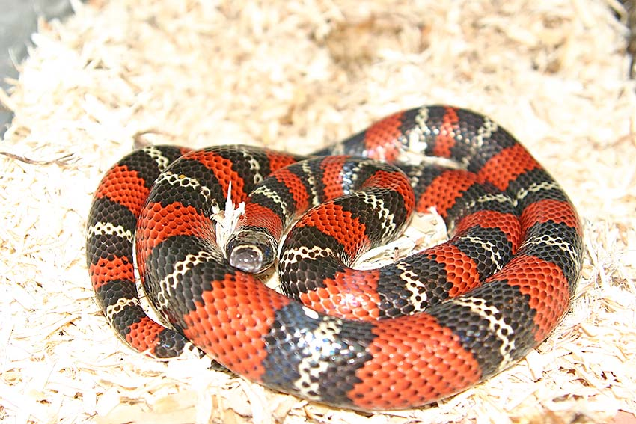
My Name is Justin. I love snakes, and my favorite sports are lacrosse, basketball, and football. I have two snakes, a California king snake, and a milk snake.
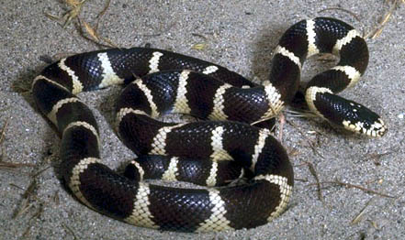



Reggie Bush:
Dwight Howard: My favorite football player
My favorite
Basketball player

My Family
Name | Age
Eliza | 19
Emilee | 17
Jamie | 15
Jeffrey | 15
Me | 12
Taylor | 10
Joseph | 7
Jake | 4
Jessie | 2


Pizza is my favorite food

Snakes
Snake hunting
Football
I play for Amelia
Basketball
I play for Amelia
Lacrosse
I play for Eastside
My Hobbies

**Video**

