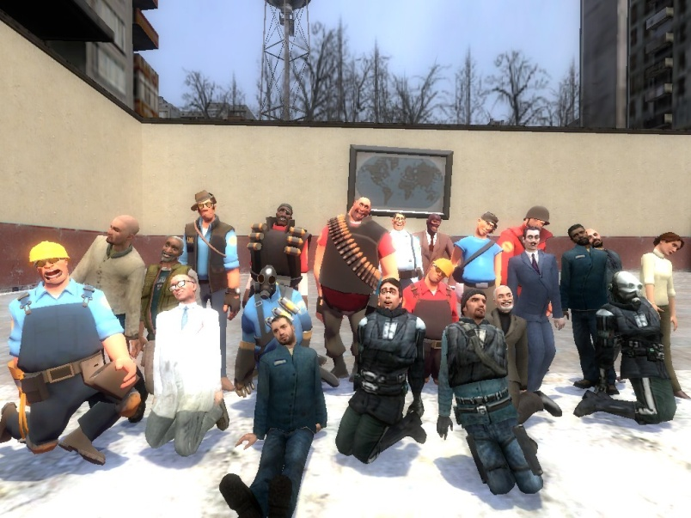
All about GMod TV

GMod TV is a series of videos made using a program called Garry’s Mod (GMod). The series was created in 2008 by Charles Cameron Smith (DRCAM). The videos can be seen on YouTube.

It takes around a week or possibly less to make a video for GMod TV. The first step I take when making a GMod TV video is thinking up a idea, then I pick out some characters to use and put them in the location I want them. Then I pose them and take pictures and then pose them again and take more pictures. That’s the normal process while “Filming.”

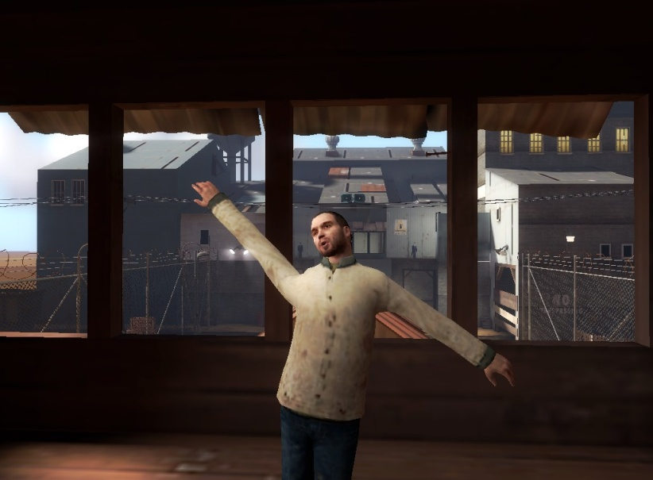

After filming I put all the clips together and add music and sound. The sound I get off the internet, or if I’m making a long story I do my own voice acting.
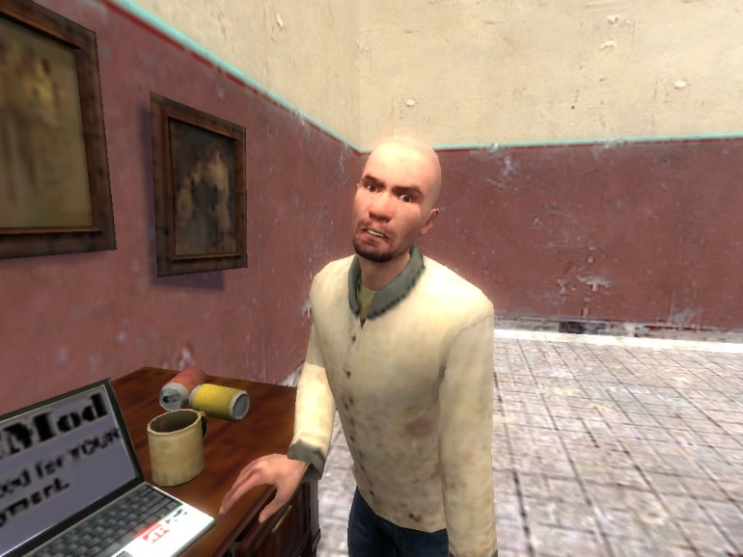
After all these things are done I upload it on Youtube with a TV related name like…”Off air”, “New episodes”, “Reruns”. After all this hard work I work on the next video and everything happens all over again.
